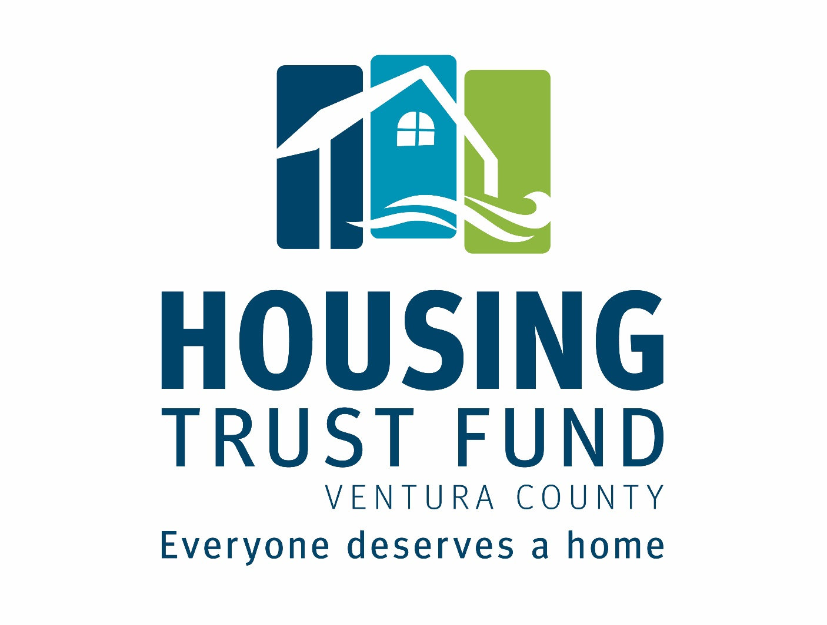

Revolving Loan Fund

Loan Review and Underwriting Guidelines

Housing Trust Fund Ventura County
Linda Braunschweiger, CEO
(805) 407-2455
Linda@HousingTrustFundVC.org
www.HousingTrustFundVC.org
Introduction

This document summarizes the Loan Review Process and Underwriting Guidelines for the Housing Trust Fund Ventura County (HTFVC). Its purpose is to convey our current standards, process and practices to prospective borrowers and investors.

The Loan Review Process describes the general steps that the HTFVC takes when working and communicating with prospective borrowers, reviewing applications and approving loans. The Underwriting Guidelines describe how we review and evaluate loan applications and the standards upon which we base our lending recommendations and decisions.

The process and guidelines described in this document are driven by the mission and values of the HTFVC. Our mission is to support more housing choices, by generating and leveraging financial resources, working in partnership with the public, private, and non-profit sectors throughout Ventura County. In addition, HTFVC works to increase the supply of affordable housing for extremely low, very low, low and moderate income residents of Ventura County. This mission is served by providing financing for the development and acquisition/conversion (conversion of nonresidential or market rate residential to affordable units) of new affordable housing that will remain affordable for the longest possible time.

HTFVC was created to provide an additional source of financing for affordable housing developments. We fill a niche between bank loans and government housing programs. It is our policy to cooperate with banks and other private lenders. While HTFVC does not directly compete with banks, we are not a lender of last resort nor do we require rejection letters as part of our application package. When it appears that an applicant may qualify for bank financing, HTFVC will request that they approach a bank for financing. Rather than delay the development while the bank processes the loan, HTFVC can process it concurrently to help expedite the development.

Loan Review Process

HTFVC will conduct an initial review of the development within 30 days and notify the applicant if a formal development loan application will be considered. Upon receipt of the formal loan application, HTFVC will review and underwrite the application package. The Underwriting Committee will make recommendations to the HTFVC Board of Directors which has final authority for loan approval. (The HTFVC follows an approved Code of Ethics Policy which includes conflict of interest guidelines.)

Initial Inquiry
Potential applicants are encouraged to email the HTFVC’s staff to describe their developments and discuss their financing needs. A meeting may be arranged for a more extensive review. Prospective applications may be discussed with the Underwriting Committee and/or the Board for policy guidance and/or to discuss priorities for the use of available funds.

Application Review

HTFVC will review, analyze and underwrite the applications. Preliminary title reports, environmental reports, appraisals or indicators of value, and other third party reports may be required from applicant. Follow-up information and/or documentation may be requested from the applicant. The package will then be sent to an independent underwriter for evaluation. After underwriting and determining that developments meet the HTFVC’s requirements, reports will be prepared and submitted to the Underwriting Committee. The reports will describe the applicants and their developments; analyze various risks and recommend loan terms and conditions.

Board approval

Formal reports will be prepared for the Board of Directors that outline the Underwriting Committee’s considerations and recommendations on each application. A presentation on the application(s) and Underwriting Committee recommendation(s) will be made to the Board. The Board considers and makes the final decision regarding each application. The Board may concur with the recommendations of the Underwriting Committee or may deny applications or approve them with different terms or conditions.

Underwriting Guidelines

Underwriting is the process of evaluating whether 1) the request meets our eligibility and targeting requirements, 2) the development is viable, and 3) whether the sponsor has the ability to perform, and 4) the loan should be recommended for approval. The underwriting of affordable housing developments is an involved process. These Guidelines include a chart that summarizes many of the standards that HTFVC will use in underwriting applications. This chart is followed by short discussions of these and other underwriting considerations.

The fiscal soundness and integrity of HTFVC are dependent on the successful repayment of all of the loans that we make. Consequently, we tend to focus on the following three areas when underwriting a loan application:

- Whether the development will be completed successfully
- Whether our loan will be repaid as scheduled
- Whether we have adequate loan collateral in case something goes wrong

To the greatest extent possible, HTFVC relies on documents that are produced for other lenders or other purposes when underwriting a requested loan. Such documents may include, but not be limited to, application forms, budgets and financial analyses, appraisals, environmental assessments, engineering reports, plans and specifications, market studies and financial statements.

Underwriting Guidelines Table

Eligible Borrowers | Any legal entity including individuals, partnerships, corporations, public agencies or any combination thereof.
Eligible Developments | Affordable rental housing including transitional housing, mixed income developments and mixed use developments.
Eligible Use of Funds | Development planning and predevelopment, site development, construction, acquisition/conversion for new affordable units or to fill financing gaps.
Income Targeting | Extremely low, very low, low and moderate income households.
Location of Development | HTFVC will only finance developments located in Ventura County.
Collateral Required | The underlying real property of the subject development. Additional collateral may also be required.
Location of Collateral | Negotiable.
Min/Max Loan Amounts | $ 50,000 minimum loan amount; $2,000,000 maximum for a single loan and the total of all HTFVC loans to a single project.
Interest Rate | Rate will be set at time of issuance of underwriting.
Underwriting Fee | A $750 underwriting fee will be collected at time of loan closing.
Application Fee | A non-refundable application fee of $500 is required to be submitted with the full application. If a preliminary application is requested, half of the fee amount shall be submitted with the preliminary application.
Loan Documentation Fee | Any loan documentation fee charged will be paid at closing. Amount will be based on complexity of loan documents and associated Attorney costs.
Loan Fee | 1.0% of loan amount due at closing.
Escrow Fees | An escrow will be required. Fees and requirements of that escrow are the responsibility of the borrower.
Max. Loan to Value Ratio (LTV or CLTV) | Up to 120% (including any senior debt) depending on the specific characteristics of the development and borrower.
Maximum Loan Term | Typically 24 to 60 months depending on the amount, purpose, project and borrower. Longer and shorter loan terms will be considered.
Required Payments | Typically accrued interest is paid monthly during the term of the loan with principal due at maturity. Quarterly interest payments or an interest reserve can be considered. There is no principal early repayment penalty.
Repayment Ability | Borrower must demonstrate ability to meet Required Payment in addition to all other existing debt payments. An interest reserve or other revenues of the borrower may be used to satisfy this requirement.
Source(s) of Repayment | Must be identified and may need to be committed in writing.

Waivers and Exceptions

The Board may, at its sole discretion, approve a loan that does not conform with all of these underwriting guidelines if approving the loan will provide significant benefits to the local community or HTFVC. Each loan request is evaluated on its own merits. The Board has the authority to approve a loan with one or more waivers and/or exceptions to these guidelines. The nature and extent of these waivers and/or exceptions may vary at the sole discretion of the Board. The following are specific waivers and/or exceptions that the Board has indicated it will consider.
Extremely Low Income (ELI) Developments
HTFVC’s contract for the Local Housing Trust Fund Grant Program (LHTF) requires that 30% of the funds in our LHTF Program (the LHTF award plus the required matching funds) must be used to finance units for households with extremely low incomes (up to 30% of the area median income). The Board will consider approving a limited number of loans, grants, or deferred loans for ELI developments at a lower interest rate in order to meet this contractual requirement.

Predevelopment Loans
HTFVC offers a Predevelopment Loan product to encourage and assist developers in moving a potential development forward. Predevelopment Fees and/or pledged security may be reduced or waived on a case by case basis.

Fair Housing and Discrimination
HTFVC is an equal opportunity lender. We affirmatively support State and Federal fair housing and anti-discrimination laws and requires our borrowers to do the same.

HTFVC offers financing for housing that is targeted for special needs populations or for specific income groups (veterans, homeless individuals and families, youth transitioning from foster care, and farm workers). While this housing is not available for the general public, the owners and sponsors of these developments may not unlawfully discriminate based upon race, ethnicity, religion, and source of income or other factors.

Borrower’s Capacity and Financial Strength

The borrower’s capacity and financial strength are very important considerations when evaluating whether an affordable housing development will be successful. Ideally, the borrower should have experience successfully completing housing developments that are similar in type and scale. When borrowers do not have direct experience, the experience of their advisors and other team members will be considered. We may also consider training and related experience when evaluating the borrower’s capability.

HTFVC reviews the borrower’s financial statements and/or income tax filings for at least the past two years plus the current year to date to evaluate whether there is sufficient income, equity and cash flow to undertake, carry out and successfully complete the proposed development. Co-borrowers and guarantors will be considered in this evaluation.

Development Evaluation

We review and evaluate the development from a number of perspectives, including the following:
Environmental Assessment
Once a development is eligible for financing we may request an environmental assessment for the property that will be used as collateral for our loan. We require a Phase 1 environmental assessment for all our loan types. Other environmental reports may be required.

Development Approvals
We will review the development approvals that are necessary to complete the development and the development’s current status in the development review and approval process to identify and evaluate risks that the development may not be approved or that the approvals will be delayed significantly. A request for a Predevelopment Loan requires a submittal of a development confirmation letter/form from the governing jurisdiction that states the development conforms to the General Plan land use designation. Applicant shall provide a clear timeline or schedule that lists the public reviews and approvals that are needed to complete the development, the development’s current status and the dates that reviews and approvals have been and will be received.

Development Budgets and Financing
We will review and analyze the development’s pro-forma budgets. We will also review and confirm the financing commitments that the development has received. We require that the development have commitments for the key sources of permanent financing for all but predevelopment loan applications.

Sources of Repayment
As noted above, we need to ensure that the developments we finance will be able to repay our loans on schedule. During the term of our loan, we will verify that the development or the borrower has sufficient income and cash flow to repay our loan. The borrower may be required to provide updated financial information as requested. We will consider financing an interest reserve.

Loan Collateral

Properties that serve as collateral for our loans shall have sufficient value to support the loan. We may subordinate our liens to other financing under acceptable terms and conditions.

Appraisals or Indicators of Value

Borrower shall provide a current existing appraisal. HTFVC reserves the right to require an updated appraisal or other indication of value as deemed necessary.

Other

HTFVC reserves the right to review and consider other matters as part of the review, underwriting and approval of loan applications.

For additional information, please contact the Housing Trust Fund at:

Linda Braunschweiger, Chief Executive Officer
Housing Trust Fund Ventura County
805-407-2455
Linda@HousingTrustFundVC.org

The various income limits that HTFVC use are posted online at www.HUD.gov. The income limits are updated annually.
HTFVC cannot provide financing that is secured by owner-occupied homes.
HTFVC has various sources of funds. Some have specific income targeting requirements. HTFVC will finance mixed income developments that include market rate units. See our income limits at www.HousingTrustFundVC.org.
See the separate Program Guidelines at www.HousingTrustFundVC.org.

