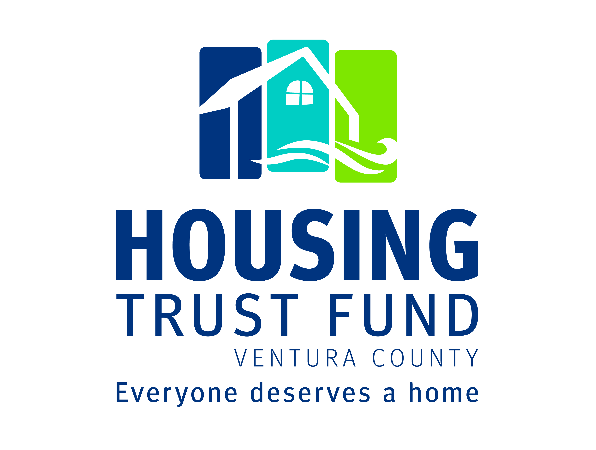

Revolving Loan Fund

Full Application

Housing Trust Fund Ventura County
Linda Braunschweiger, CEO
(805) 407-2455
Linda@HousingTrustFundVC.org
www.HousingTrustFundVC.org
Revolving Loan Fund Application Submittal Checklist
Please submit the following documents in the order listed below and check off to indicate that the information is included. If an item is not relevant to your development, you can write NA (Not Applicable) beside the check box. Failure to submit any of the required documents may result in your application being incomplete. Please submit one clearly marked original application, one additional copy, PLUS a thumb drive or email version of the complete application with attachments.
Application Submittal Checklist (Place at the beginning of your application)
Completed Development Application Form
Digital file: Completed application in Microsoft Word for a PC by email or thumb drive.
Development Information:
Appendix 1: Preliminary Title Report and Evidence of Site Control
Appendix 2: Evidence of Local Development Approvals
Appendix 3: Development Location Map
Appendix 4: Development site plan, floor plans, landscaping plan and elevations and photos
Appendix 5: Phase I Environmental Report (upon request only)
Appendix 6: Market Study or proposed rent rolls (upon request only)
Appendix 7: Marketing and Property/Asset Management Plan (upon request only)
Appendix 8: Pro Forma with development costs; sources and uses; 15-year operating cash-flow projection
Appendix 9: Construction description and cost estimates.
Appendix 10: Evidence of Financial Commitments
Appendix 11: Development Timeline with major development milestone dates.
Appendix 12: Long-term affordability control documents
Appraisal: A copy of a current (within 6 months) recognized certified appraisal will be needed.
Please check box to indicate that you have contacted HTFVC regarding appraisal requirements.
Agency Information:
Appendix 13: Partnership Agreements and Partner Information
Appendix 14: Corporate or Public Agency Resolution to Borrow
Required for first time borrowers:
Appendix 15: Board of Directors list and background
Appendix 16: Agency organizational chart
Appendix 17: Development Team Resumes and References
Appendix 18: Summary of Sponsor development experience
Appendix 19: Tax returns, audited financial statements and current
Appendix 20: Evidence of Hazard and Liability insurance coverage or bonding for the development.
Appendix 21: Articles of Incorporation, By-Laws, IRS Tax exempt determination letter and Certificate of Good Standing for nonprofit applicants.

1. Development Information:
Development Name:

Address: | City
Zip Code: | Census Tract:

2. Sponsor Information:
Agency/Firm Name:

Contact Person: | Telephone/Fax:
Address: | City: | Zip Code:
Email: | Web-Site:

3. Borrower Entity (if different from sponsor):
Contact for Additional Information: | Telephone:

4. Loan Request and Development Type:
Loan Amount Requested: $  Requested Loan Term:  Rate Requested:  Appraised Value: $  Total Other Financing: $  Loan to Value Ratio: | Loan Type:  Bridge financing  Predevelopment  Construction  Acquisition/Rehab  Land Acquisition  Line of Credit  Long-term Residual Receipts
Development Type: (check all that apply)  Rental  Homeownership  Mixed-use  Scattered Site (Group Homes)  Cooperatively owned  Multi-family  Single-family  Rehabilitation/Rental | Self-Help  Farmworker  Homeless  Transitional Youth (16-24)  Veterans  SRO  Seniors  Special Needs  Other, Specify:
Date Funds are Needed: | Projected Construction Start Date (Specify):
5. Development Summary: Provide a concise description of the development, including: development type and targeted client group; # of affordable and market units, unit size and mix; building type and architectural style; development amenities; location/access to community services; total development cost. You may attach one additional page, if needed.

6. Development Readiness:
Indicate all discretionary approvals that are required for the development, describe current status and attach documentation verifying approvals that have been obtained (see appendix list below).

General Plan Amendment Required? Yes No  Zoning Change Required? Yes No  Modifications or Variances Required? Yes No  Conditional Use Permit Required? Yes No | Site Control Achieved? Yes No  Anticipated Relocation? Yes No  Building Permits Issued? Yes No
Status of Site Control: Indicate the form of site control (e.g. deed of trust; leasehold, option, development and disposition agreement) and describe the status if full site control is not yet achieved. Attach documentation of site control in the appendices.

Development Barriers: Identify and describe any barriers to development of the development such as environmental issues or unusual site conditions, necessary land use changes or general plan amendments, required relocation assistance or neighborhood opposition and how these will be overcome.

7. Development Need: How was the development determined and how does it meet community needs?

8. Development Location: Describe the development location, setting (urban, suburban or rural) and access to community services appropriate to the client group (e.g. education, employment, transportation, shopping and service centers). Provide a location map in the appendices that clearly indicates the development location and adjacent community services.

9. Special Features: Describe development special features such as infill, neighborhood revitalization, redevelopment, mixed-use, transit-oriented, ‘smart growth’, green building design and energy efficient systems, number or size of bedrooms (large units or SRO/studio, etc.) or other special features of the development.
10. Development Amenities and Services: Please describe any development amenities, resident supportive or educational services (e.g. employment training, life skills training, daycare, recreation) and community facilities provided by the development (e.g. health clinic, daycare, public recreation or meeting space; community kitchen, etc.) (Revolving Loan Funds will not be used for services.)

11. Management/Ownership Structure: a) Describe proposed ownership and management structure and how the sponsor/owner will manage the asset and development affordability over time; b) Describe any resident involvement in the development (e.g. tenant council; association, etc.).

12. Homeowner / Resident Participation & Services: If a homeownership development, is homeowner training and counseling provided? Describe any sweat entity involved in the development. If rental development, describe any support and social services provided.

13. Development Financing:
a) Financial Structure: Briefly describe the development financial structure, including proposed or secured sources of interim and permanent financing and any terms and conditions of secured financing. Include a clear statement of how HTFVC’s loan to the development will be repaid.

b) Total Development Cost: $
Attach a Development Pro Forma showing development or acquisition costs; funding sources and uses; 15-year operating cash-flow projection for rentals or proposed sales prices for homeownership developments. Clearly indicate assumptions used in structuring the financial analysis.
c) Fund-raising: If donations are required to cover a portion of development financing, please describe your
fund-raising plan, including details on timing, solicitation and potential funding sources. Describe any
past experience in successful development fund-raising, as well as other current development fund-raising efforts.

14. Development Affordability: Development Affordability: Describe the number of affordable units, targeted income levels and the term and structure of development affordability controls. Attach copies of any affordability control documents in the Appendices.

15. Agency Experience & Capacity:
a) State Organizational Status: (nonprofit, public agency, private) | Date Incorporated:
b) Briefly describe the agency/organization mission, history and accomplishments

c) Sponsor Role: Describe the sponsor role in development and ownership/management
(e.g. developer, owner, manager, general partner); and, any sponsor development financial interests / participation.

d) Development Experience: Describe past agency experience and record of performance in developing
developments, including experience with various financing and loan programs and internal capacity to carry out the development. (Provide a summary or list of previously completed and current developments in the appendices.)

e) Has your agency ever been involved in a development that was not successfully completed or that has
experienced financial difficulties, default or management problems? If yes, please describe the situation or experience.

16. Development Team: Briefly describe the development team and their experience (e.g. development coordinator; architect/engineers; land use consultants; contractor; financial consultants; legal counsel; management entity, etc.)
Attach development team resumes and references in the appendices.
17. Development Partners: List each partner involved with the development/program (owner, property manager, sponsor, managing general partner, general contractor, etc.). Describe the organizational relationship of each entity with the other if applicable. (Provide requested partner information in the appendices.)

18. Development Timeline: Provide a development timeline with major development milestones (e.g. site control;
local approvals; funding application dates; construction start; completion and occupancy; anticipated escrow closing, etc). You may outline here or attach a timeline in the appendices.

19. Certification: The applicant certifies that the information in this application is correct and that the financial assistance provided by the Housing Trust Fund Ventura County will be used only as set forth in this Application
and in compliance with applicable laws and regulations.

Borrower Development Sponsor (if different)
Authorized Signature

Name (Print or Type)
Title
Date Signed

Application Instructions:
Please return one (1) original application (with original signatures) and one additional copy of the complete application with required attachments. In addition, please provide a digital version of the application by email or thumb drive. Include the $500 non-refundable application fee. The application, including all attachments, should be returned to the Housing Trust Fund at the address indicated below. Applications will not be accepted by Fax.

Mailing or Hand Deliver to:  Housing Trust Fund Ventura County  Attn: Linda Braunschweiger  360 Mobil Ave., Suite 213A  Camarillo, CA 93010 | Email Version to:  Linda@HousingTrustFundVC.com

For More Information or Questions about the application, please contact Linda Braunschweiger at the Housing Trust Fund Ventura County at (805) 407-2455 or email: Linda@HousingTrustFundVC.com.

Required Documentation:
Please provide documents relevant to your specific development, as listed in the Appendices on the following page.

Appraisal Requirements:
An appraisal may be commissioned, at the borrower’s expense, by the HTFVC lending partner(s) funding the development loan request. An existing appraisal requested by another lender to the development may be acceptable. The appraisal must be acceptable to HTFVC and its participating lender(s) and meet the standards of an FDIC insured institution. HTFVC and its lending partner(s) will work with the applicant to make arrangements for the appraisal. Please contact HTFVC at (805) 407-2455 or email: Linda@VCHousingTrustFund.com to discuss the appraisal requirements.

An Environmental Questionnaire, Flood Determination Certification and Asbestos or Lead-based Paint Surveys may be required by HTF lending partners as part of loan processing and escrow closing, depending upon the development circumstances.
The marketing plan should describe the income certification process for affordable units. The asset management plan should describe the ownership structure and long-term affordability controls.

